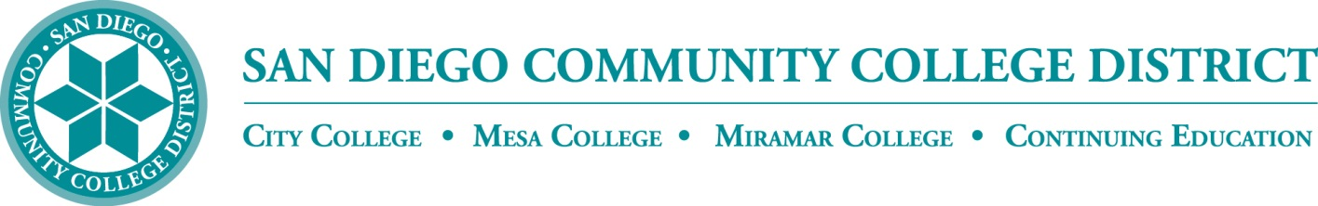**BP 4100**

**Board Policy**

Chapter 4 – Academic Affairs

**BP 4100 GRADUATION REQUIREMENTS FOR DEGREES AND CERTIFICATES**

**References:**

Education Code Section 70902(b)(3);

Title 5 Sections 55060 et seq.

The ~~San Diego Community College~~ District’s colleges grant the degrees of Associate of Arts and Associate of Science to those students who have completed the requirements for graduation and who have maintained a 2.0 grade point average in courses attempted as prescribed by Title 5 regulations and the faculty. Students must also complete the general education, residency, and competency requirements set forth in Title 5. Associate in Arts and Associate in Science degrees shall be approved by the colleges’ curriculum committees, Curriculum and Instruction Council, the Board of Trustees, and the California Community Colleges Chancellor’s Office.

The colleges may grant the Associate in Arts for Transfer (AA-T) and Associate in Science for Transfer (AS-T) degrees to those students who have completed the requirements for graduation prescribed by Title 5. These degrees are intended for students who plan to complete a baccalaureate degree in a similar major at a CSU campus. Each AA-T or AS-T is accepted by some but not all CSU campuses.

Approved colleges may grant the degree of Bachelor of Science degree to those students who have completed the program requirements for graduation and who have maintained a 2.0 grade point average in courses attempted as prescribed by Title 5 regulations, accreditation requirements, and the faculty. Students must also complete the general education, residency, and competency requirements set forth in Title 5. Bachelor of Science degrees shall be approved by the colleges’ curriculum committees, Curriculum and Instruction Council, the Board of Trustees, and the California Community Colleges Chancellor’s Office.

The colleges may award the Certificate of Achievement to those students who have completed an approved sequence of courses consisting of 18 or more semester units, or alternatively 12 to 17.5 semester units of degree-applicable credit coursework and who have maintained a 2.0 grade point average in courses attempted as prescribed by title 5 regulations and the faculty. Such certificates shall be designed as a pattern of learning experiences considered to develop certain capabilities that may oriented to career or general education. Certificates of Achievement shall be approved by the colleges’ curriculum committees, Curriculum and Instruction Council, the Board of Trustees, and the California Community Colleges Chancellor’s Office.

The colleges may award the Certificate of Performance, consisting of less than 18 units, without California Community Colleges Chancellor’s Office approval after approval by the colleges’ curriculum committees, the Curriculum and Instruction Council, and the Board of Trustees. Certificates of Performance are department awards which signify the completion of a related set of courses as determined by the faculty. Certificates of Performance do not imply that graduation requirements have been met and shall not be listed on a student’s transcript.

Continuing Education may award the noncredit Certificate of Completion or Certificate of Competency for the attainment of applicable competencies learned in a pattern of noncredit courses as prescribed by title 5. Certificates of Completion shall be approved by the Continuing Education curriculum committee, Curriculum and Instruction Council, the Board of Trustees, and the California Community Colleges Chancellor’s Office.

The District Chancellor or designee shall establish procedures to determine degree and certificate requirements that include appropriate involvement of the local curriculum committees. The procedures shall assure that graduation and program requirements are published in the ~~San Diego Community College~~ District’s Colleges and/or Continuing Education catalogs and included in other resources that are convenient for students.

See Administrative Procedures: To Be Determined

~~References:~~

~~Title 5 Sections 55060 et seq. Education Code Section 70902(b)(3)~~

~~Adopted: 5/27/10~~

~~DRAFT~~

|  |  |
| --- | --- |
| **Adopted:** May 27, 2010  **Revised:** |  |
| *(Replaces current SDCCD BP 5100)* |  |